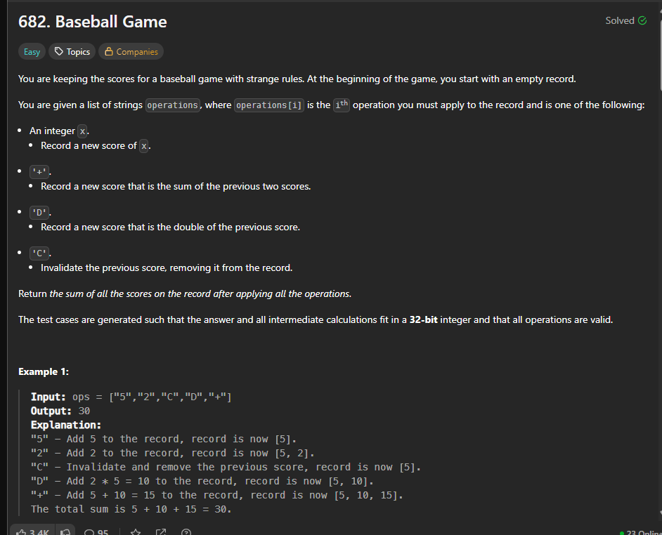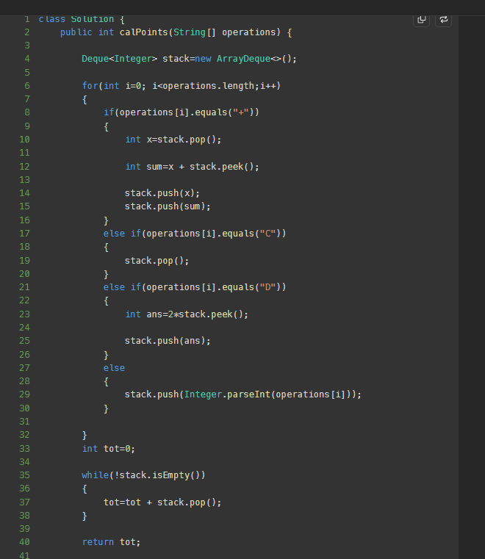

TIME COMPLEXITY- O(2N) – O(N)
SPACE – O(N)

